COMSATS University Islamabad, Lahore campus

COAL Mid Term Lab Exam
Submitted to: Sir Hamza Hamid
Submited by: Samiullah Ashfaq
SP24-BSE-107
Section A

Question 1:
MOV AX, 0107H ; Roll number value
MOV BX, 7010H ; Reverse roll number value
MOV CX, 0C042H
ADD AX, BX
ADD BX, CX
SUB CX, AX
SUB BX, AX
After 1st add:
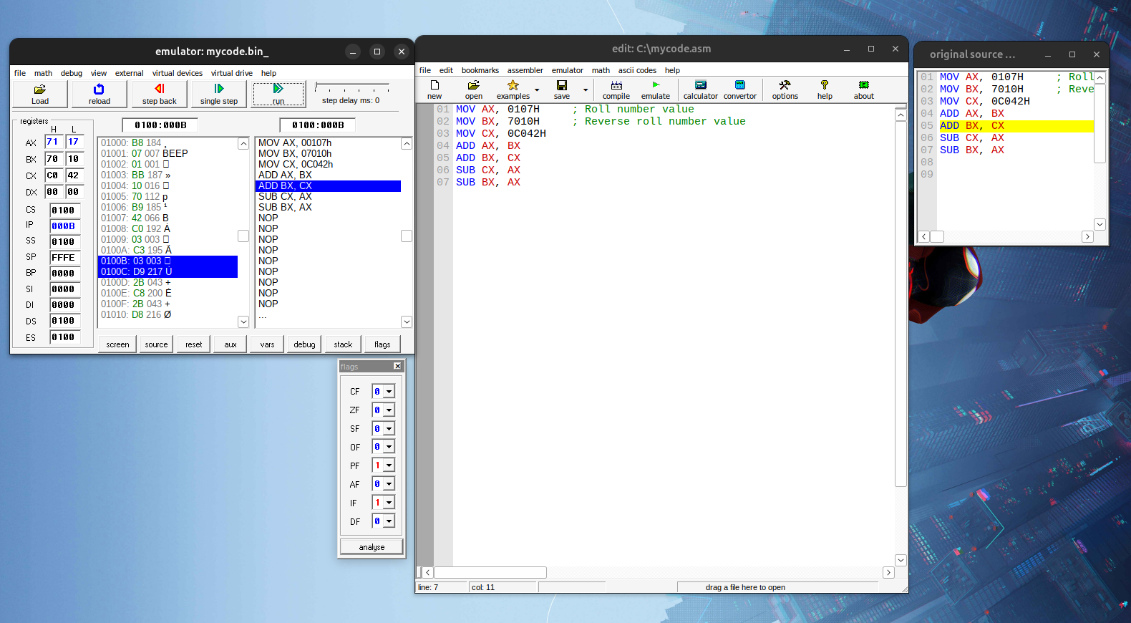
Step-by-Step Execution
1st ADD: ADD AX, BX
- AX = 0107H + 7010H = 7117H
- AX = 7117H
- BX = 7010H
Part (a) — After 1st ADD instruction
AX = 7117H
Flag | Value | Reason
CF | 0 | 0107H + 7010H = 7117H which is ≤ FFFFh — result fits in 16 bits, no carry out of bit 15 → CF = 0
ZF | 0 | Result 7117H ≠ 0000H, so the Zero Flag is NOT set → ZF = 0
SF | 0 | MSB (bit 15) of 7117H = 0 (0111 0001 0001 0111), meaning the result is positive

After 1st sub:
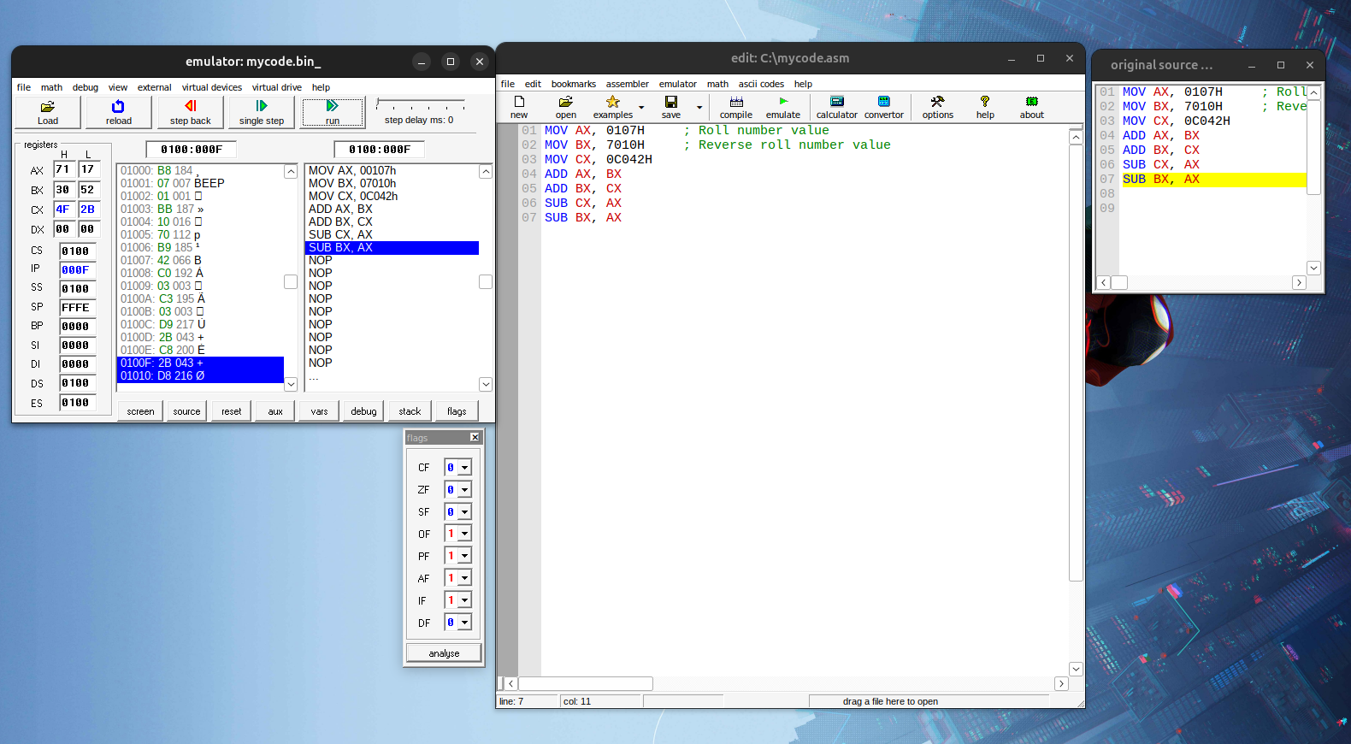
Part (b) — After 1st SUB instruction
1st SUB: SUB CX, AX
- CX = 0C042H − 7117H = 4F2BH
Flag | Value | Reason
OF | 1 | The result (4F2BH) has an MSB of 0, meaning it is positive. This "sign flip" indicates a signed overflow occurred.
AF | 1 | he sum of the lowest 4 bits is 1011. Since a borrow was required in the original subtraction, AF is set to 1.
PF | 1 | The result is 4F2BH. The low byte is 2BH. Binary of 2BH: 0010 1011. Count the number of 1s: There are four 1s. Since 4 is an even number, the Parity Flag is set to 1 (Even Parity).

Question 2:

a. JE — Check if BL = 5
ORG 100h

MOV BL, 5 ; Input value
CMP BL, 5 ; Compare BL to 5
JE is_equal ; Jump if Zero Flag is set (BL - 5 = 0)

; If not equal
MOV AH, 2
MOV DL, 'N' ; Display 'N' for Not Equal
INT 21h
JMP finish

is_equal:
MOV AH, 2
MOV DL, 'Y' ; Display 'Y' for Equal
INT 21h

finish:
RET ; Return to OS
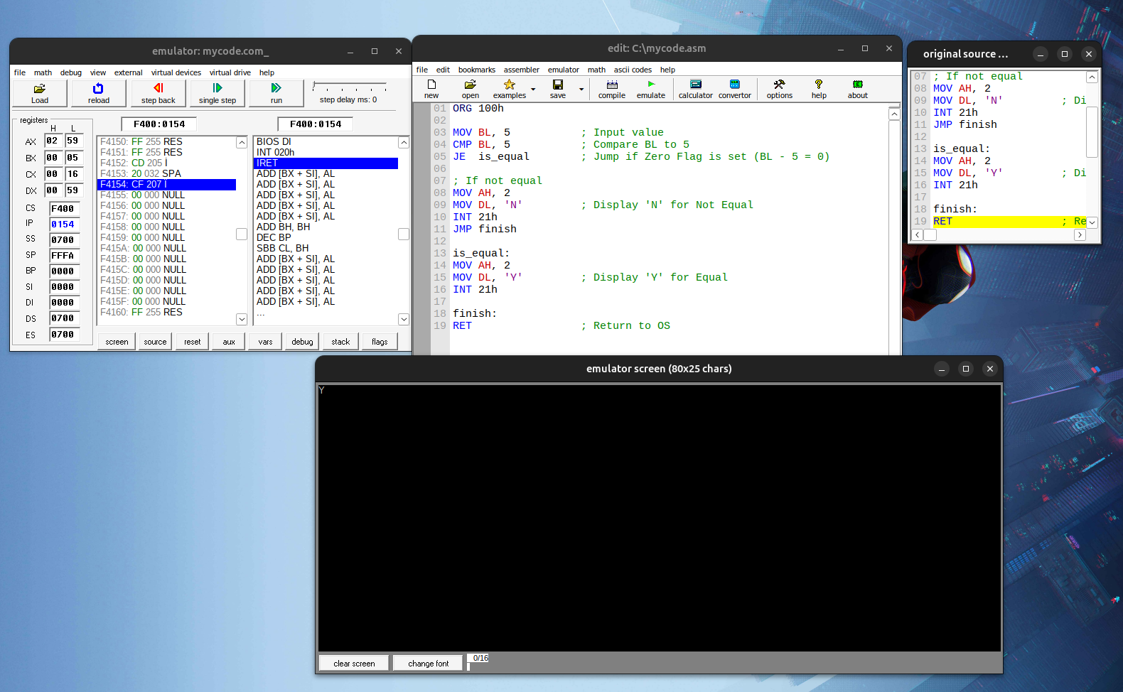

b. Print Y if CL = 20, else N
ORG 100h

MOV CL, 20 ; Input value
CMP CL, 20 ; Compare CL to 20
JE print_y ; If CL == 20, jump to print_y

; Else: Print 'N'
MOV AH, 2
MOV DL, 'N'
INT 21h
JMP exit_prog ; Jump over the 'Y' logic

print_y:
MOV AH, 2
MOV DL, 'Y'
INT 21h

exit_prog:
RET
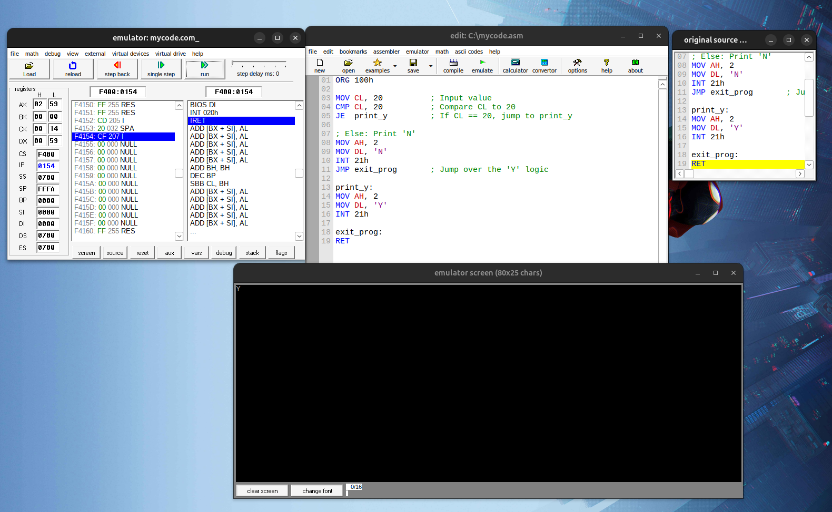

c. Display D to I using LOOP
ORG 100h

MOV CX, 6 ; Loop 6 times (D, E, F, G, H, I)
MOV DL, 'D' ; Initial character 'D'
MOV AH, 2 ; DOS function to print character

char_loop:
INT 21h ; Print the character currently in DL
INC DL ; Move to next ASCII character (e.g., 'D' -> 'E')
LOOP char_loop ; Decrement CX. If CX != 0, jump to char_loop

RET
